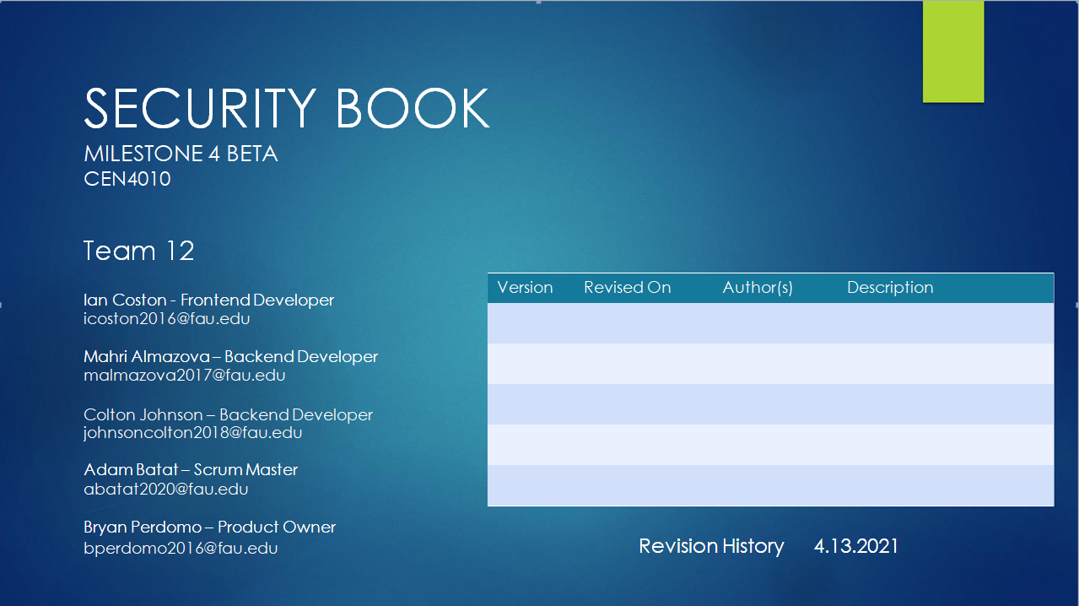
Revisions-04/04/21-Adam B-Milestone 3 Revisions
Revisions-04/04/21-Adam B-Milestone 4 Revisions

Product Summary – Security Book

Major Committed Functions:

- Register – Users will be able to input their information securely to create a new account
- Login – Users will be able to securely access their account and Security Book
- Create/Edit Profile – Users will be able to customize their profile, editing their username, email, first name, etc.
- Reset Password – Users will be able to change their password in case they forget.

Unique Features:

Security Book is social media that values your privacy, so the only data we ever store is to correctly authenticate valid users. Additionally, we don’t use your personal data to serve targeted advertisements or track you across different websites.

URL: https://lamp.cse.fau.edu/~cen4010_s21_g12/Security-Book

Usability test plan
Test Objectives:
The function we will be testing is the insertion of names and passwords into the database. When a user creates an account, the account must be stored in the database so they can access the same account again. In order for this to happen, we must implement a database connected to the website. Our test objectives are to make sure that the users first and last name is stored in the database, as well as their password. When a new account is entered into the database, a unique ID will be given to each account, to ensure no duplicate accounts.
Test Plan:
To test the database, the tester must first open up the approved browser for testing, Google Chrome and Firefox. The tester must navigate to the website, https://lamp.cse.fau.edu/~cen4010_s21_g12/ , and select the registration option. The website will prompt the tester for a first name, a last name, and a password. The tester must input their information, and from there, the website will store all the information entered into the database. The database will store each account with a unique account ID. Each tester should test this function at least three times with each browser. More tests cases should be done should there be a big problem
The intended user for this is people of various ages. Everyone who plans to use this website must create an account to enter, so this is the first step every user will need to take.

Likert Scale
The Likert scale shown below is for the tester after completing all the test cases. Should the creation of an account work perfectly and smoothly, a rating of very good or good would be expected. If the database stores all the information correctly, the rating would be very good. Finally, the database should create a unique ID for each account, so should the database do that, the tester would rank it as very good.
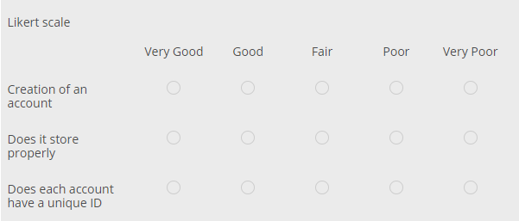

Test Objectives:

For this test plan we will be testing whether or not the database is properly being communicated with by the website. The objective of this test is to ensure that users are being entered into the database properly so that they can be properly pulled later. The users entered into the database are entered with four fields and all of these must be properly inserted.

Hardware & Software Setup:

For these tests there is not much setup. The hardware and software setup is relatively minimal, requiring a working computer and a few free to install programs. Xampp incoordination with phpmyadmin is using apache and mysql to host a local database that communicates with the webpage. The database must be properly set up through its columns and must record the 4 fields of information presented by the user.

Feature to be Tested:

The feature to be tested specifically is the database in phpmyadmin and its recordings of user-entered data. The data must be entered correctly and placed into the correct fields in the database to ensure integrity of user information. Essentially, if the database is able to properly record all of the user data, then it is a success.

Actual Test Cases:

Test | Test | Test |  |  |  |  |  | Test |  |  |  |  |  |  |  | Expected |  |  |  |  | Test Results
Number | Title | Descr. |  |  |  |  |  | Input |  |  |  |  |  |  |  | Output |  |  |  |  |  | Browser
1 | Database | Ensuring that |  |  |  |  | Test, 123, |  |  |  |  |  |  |  |  | Test, 123, |  |  |  |  | Success
 | comms | user entered |  | iandrummer9 |  |  |  |  |  |  |  |  | iandrummer9
 |  | data is |  | 87@gmail.co |  |  |  |  |  |  |  |  | 87@gmail.co
 |  | correct and in |  |  |  |  | m, (blank) |  |  |  |  |  |  |  |  | m, (blank)
 |  | the proper
 |  | columns.
2 | Database | Ensuring that |  |  |  |  | (blank), |  |  |  |  |  |  |  |  | (blank), |  |  |  |  | Success
 | comms | user entered |  |  |  |  | (blank), |  |  |  |  |  |  |  |  | (blank),
 |  | data is |  |  |  |  | (blank), hi |  |  |  |  |  |  |  |  | (blank), hi
 |  | correct and in
 |  | the proper
 |  | columns.
3 | Database | Ensuring that |  |  | Christopher, |  |  |  |  |  |  |  |  | Christopher, |  |  |  |  |  |  | Success
 | comms | user entered |  |  |  |  | Coston, |  |  |  |  |  |  |  |  | Coston,
 |  | data is |  | costonfam@ |  |  |  |  |  |  |  |  | costonfam@
 |  | correct and in |  |  | gmail.com, |  |  |  |  |  |  |  |  | gmail.com,
 |  | the proper |  |  |  |  | (blank) |  |  |  |  |  |  |  |  | (blank)
 |  | columns.
1 | Database | Ensuring that |  |  |  |  | Test, 123, |  |  |  |  |  |  |  |  | Test, 123, |  |  |  |  | Success
 | comms | user entered |  | iandrummer9 |  |  |  |  |  |  |  |  | iandrummer9
 |  | data is |  | 87@gmail.co |  |  |  |  |  |  |  |  | 87@gmail.co
 |  | correct and in |  |  |  |  | m, (blank) |  |  |  |  |  |  |  |  | m, (blank)
 |  | the proper
 |  | columns.
2 | Database | Ensuring that |  |  |  |  | (blank), |  |  |  |  |  |  |  |  | (blank), |  |  |  |  | Success
 | comms | user entered |  |  |  |  | (blank), |  |  |  |  |  |  |  |  | (blank),
 |  | data is |  |  |  |  | (blank), hi |  |  |  |  |  |  |  |  | (blank), hi
 |  | correct and in
 |  | the proper
 |  | columns.
3 | Database | Ensuring that |  |  | Christopher, |  |  |  |  |  |  |  |  | Christopher, |  |  |  |  |  |  | Success
 | comms | user entered |  |  |  |  | Coston, |  |  |  |  |  |  |  |  | Coston,
 |  | data is |  | costonfam@ |  |  |  |  |  |  |  |  | costonfam@
 |  | correct and in |  |  | gmail.com, |  |  |  |  |  |  |  |  | gmail.com,
 |  | the proper |  |  |  |  | (blank) |  |  |  |  |  |  |  |  | (blank)
 |  | columns.



Code Review
<?php

//insert.php;
$value = $_POST["first_name"]; // posts the first name
echo $value;
if(isset($_POST["first_name"])) // if the first name is given
{
$connect = new PDO("mysql:host=localhost;dbname=principles", "root", ""); $order_id = rand(); // connect to the local host, then the database named principles and than the root login
for($count = 0; $count < count($_POST["first_name"]); $count++) // increments the line in the database table
{

$query = "INSERT INTO users
(order_id, first_name, last_name, email, password)
VALUES (:order_id, :first_name, :last_name, :email, :password)
";
$statement = $connect->prepare($query); // connects to the query to input in the order listed above
$statement->execute( // executes the commands for the import
array(
// giving each database column a name to find in the code
':order_id' => $order_id,
':first_name' => $_POST["first_name"][$count],
':last_name' => $_POST["last_name"][$count],
':email' => $_POST["email"][$count],
':password' => $_POST["password"][$count],
)
);
}
$result = $statement->fetchAll(); // fetch all of the results to the database
if(isset($result)) // if all of the results are there, then continue
{
echo 'ok';
}
}
?>

SELF CHECK: NON-FUNCTIONAL SPECS
DONE

- The system will be easy to use for those without a background in technology. The common user who can access a website will be able to access the working site within 1 second of navigation to it and have the option to use SSO without issue until they decide to make an account.

- The system will respond to user action within 1 second, and a user will wait no longer than one second for their action to register unless it is slowed down due to a fault.

- The system will not store any transactional data or website visits of the users as to maintain the main principle of SecurityBook. Login information will have to be stored and encrypted to protect the users secure information.

- The system will perform under minor faults at a slower speed, up to 2 times the original functional speed. Major faults may require maintenance.

- The system will work identically on all OS types ( for example : Windows, Mac OS, and Linux) and on all common browsers ( for example : Google Chrome, Mozilla Firefox, and Safari).

ON TRACK

- The system will be available in all languages with an option to declare languages with the SSO account or the registered one. The system will also have instant-links that bring users to a specific group or personal page allowing them to connect without issue.
- The system will be able to accommodate 10,000 users at a time without issue.
- The system will be able to store login information of over 10,000 users without issue.
- The system will be available whenever a user needs to use it unless the system is under a maintenance window at which point certain features or the whole system will be unusable until there is a fix, ideally a 3 hour window in which the fix(es) can be made.

2.6.1 Major assets being protected:
- User personal information
2.6.2 Confirm that you encrypt password in the DB
The password encryption is still in progress. The plan is to have the password field in the database store MD5 hashed strings. When a user logs in, the password that was entered will be hashed and compared to the hashed string in the database. The user can login if the two hashes match.

2.6.3 Confirm Input data validation (list what is being validated and what code you used)
When a new user creates an account, our code checks to see whether the user has entered all information that is required, which is First Name, Last Name, Email and Password. The validation is done inside register.html file using if statements. There is a data function added to Submit button and when the user clicks on it, the code enters function where each variable is checked to see whether there was an input from the user. If any of the boxes were left empty an error message will appear on the screen asking to enter the missing data. Here is part of the code that checks the user input for first name:

$('.first_name').each(function() { // attached to the variable for first name
var count = 1; // set the var count to 1
if ($(this).val() == '') {
error += "<p>Enter First Name " + count + " Row</p>"; // gives an error if the first name is not inputted
return false;
}
count = count + 1; // count is incremented to the next table section
});
Once all information is collected, we send it to the database. The search bar input data validation is still in progress.

Screenshots of actual final products shown in the demo
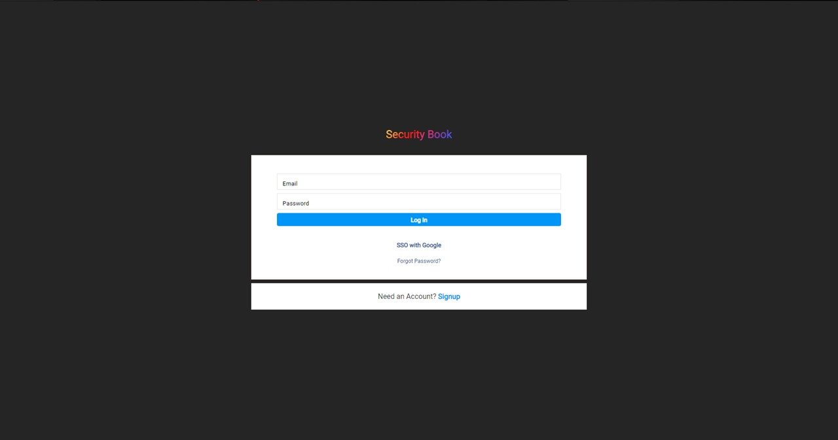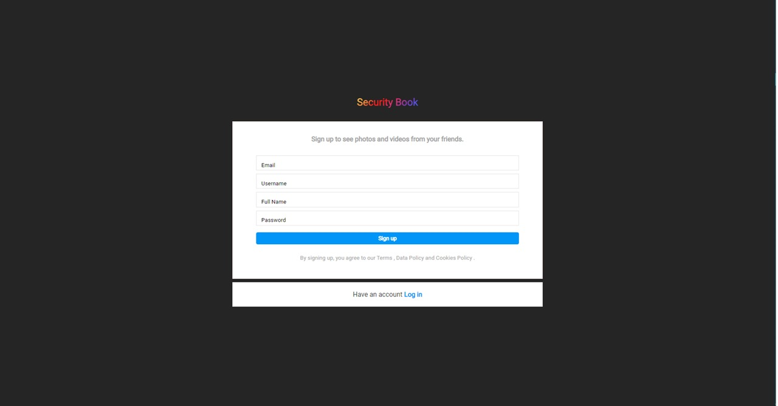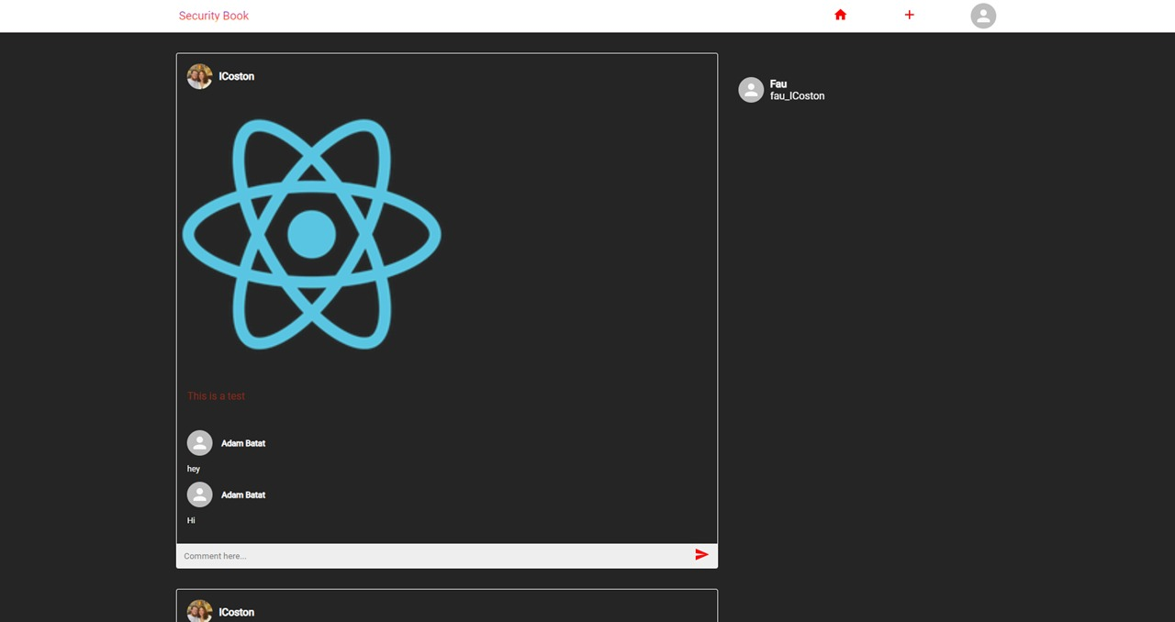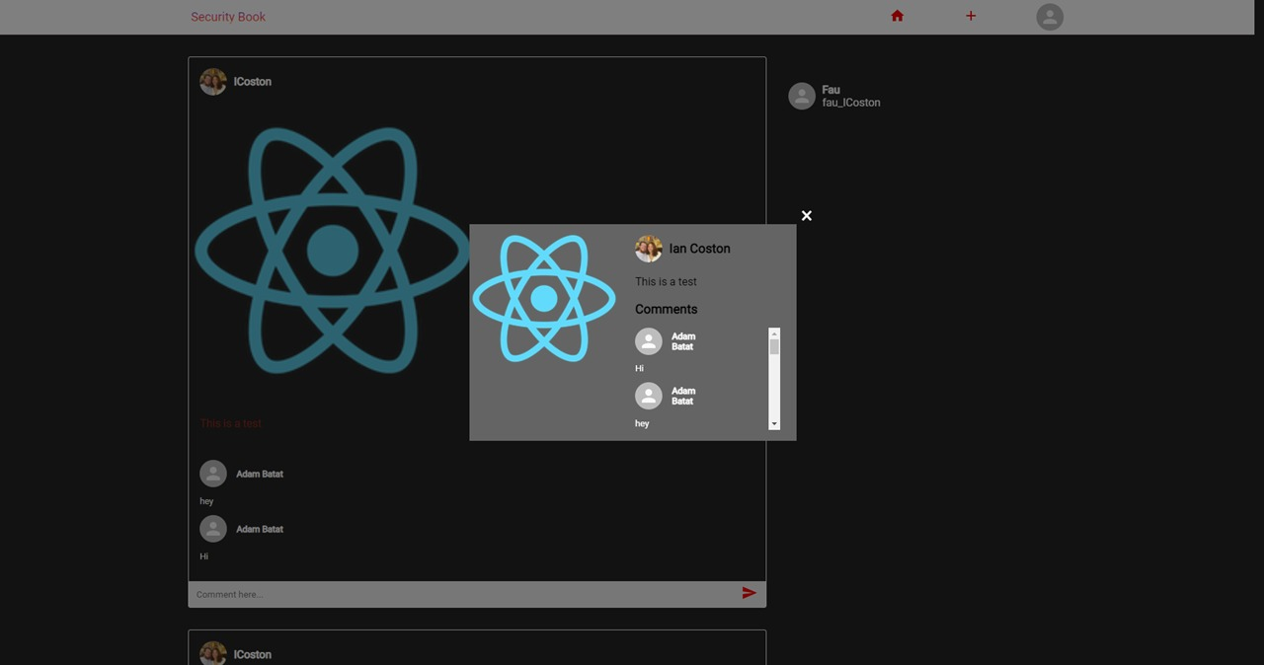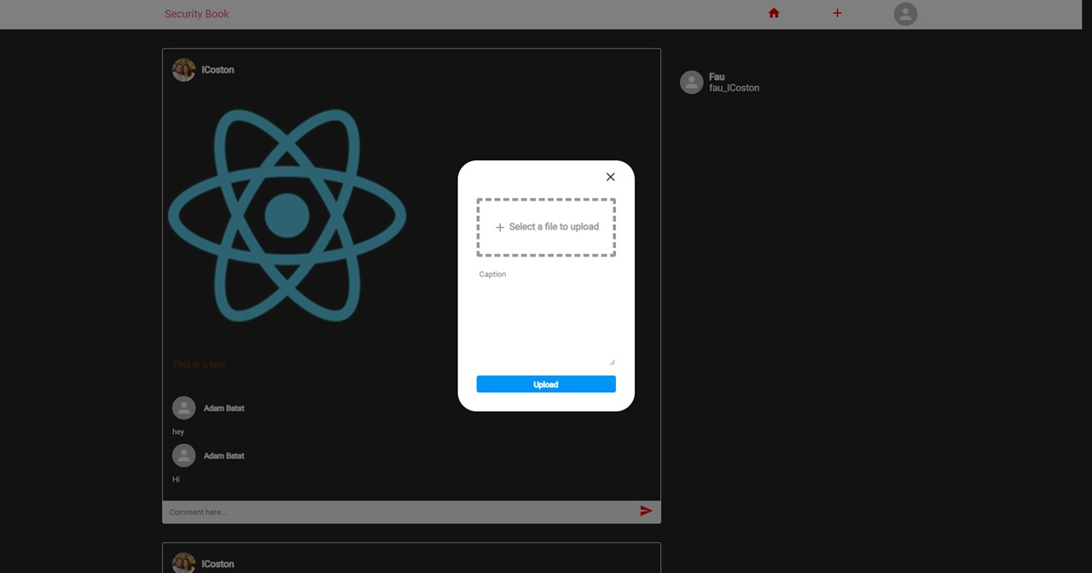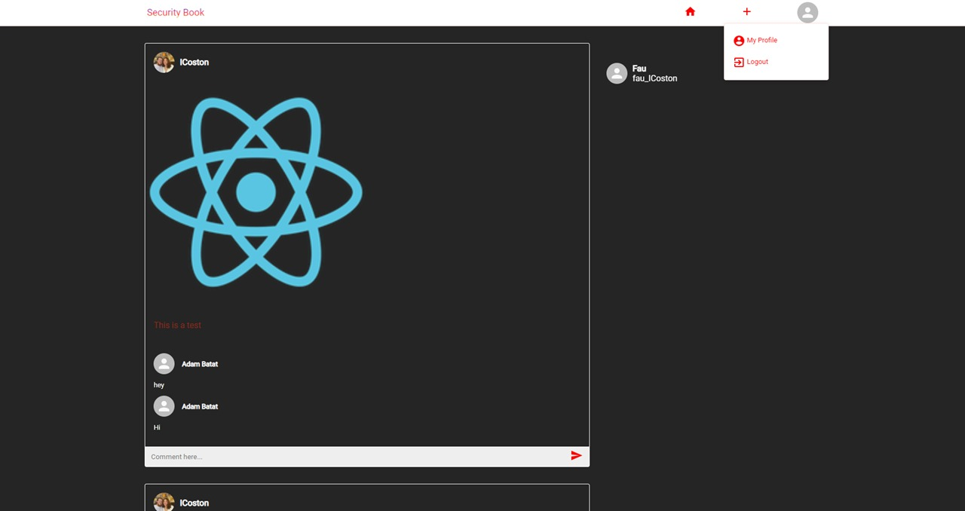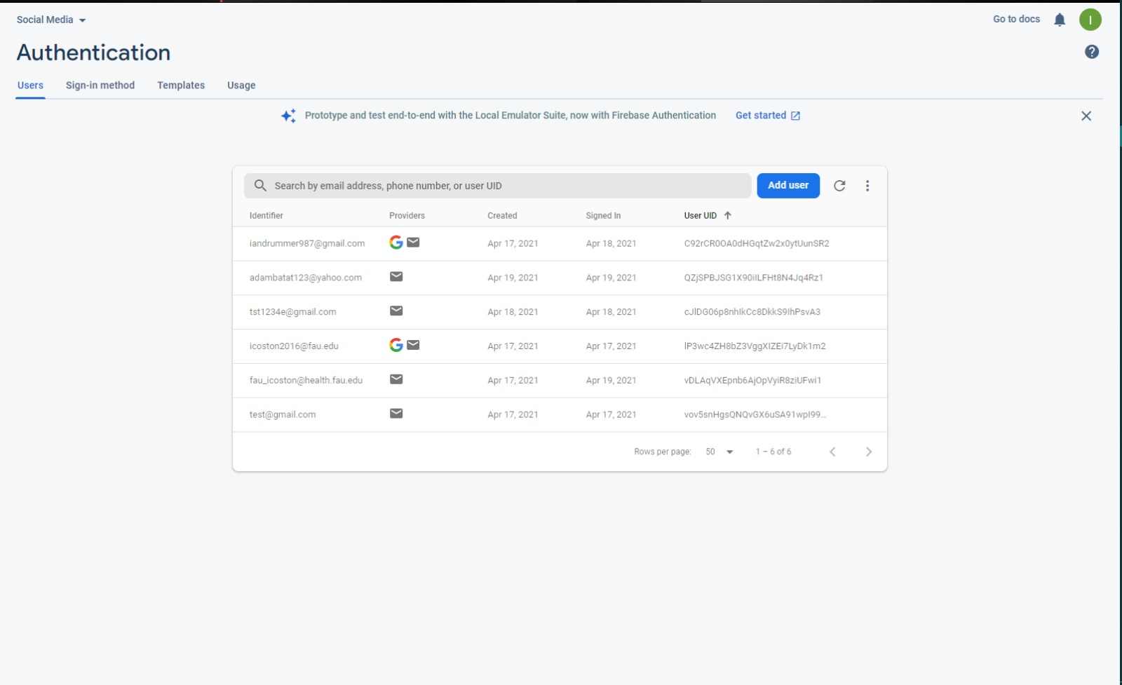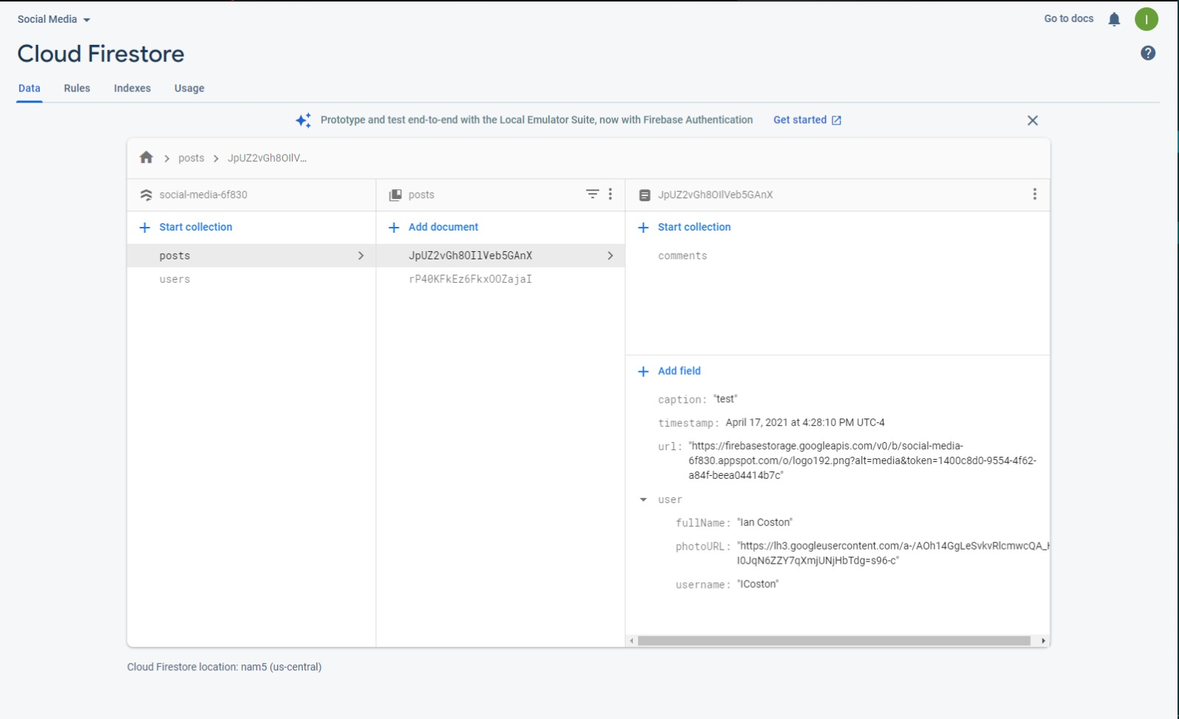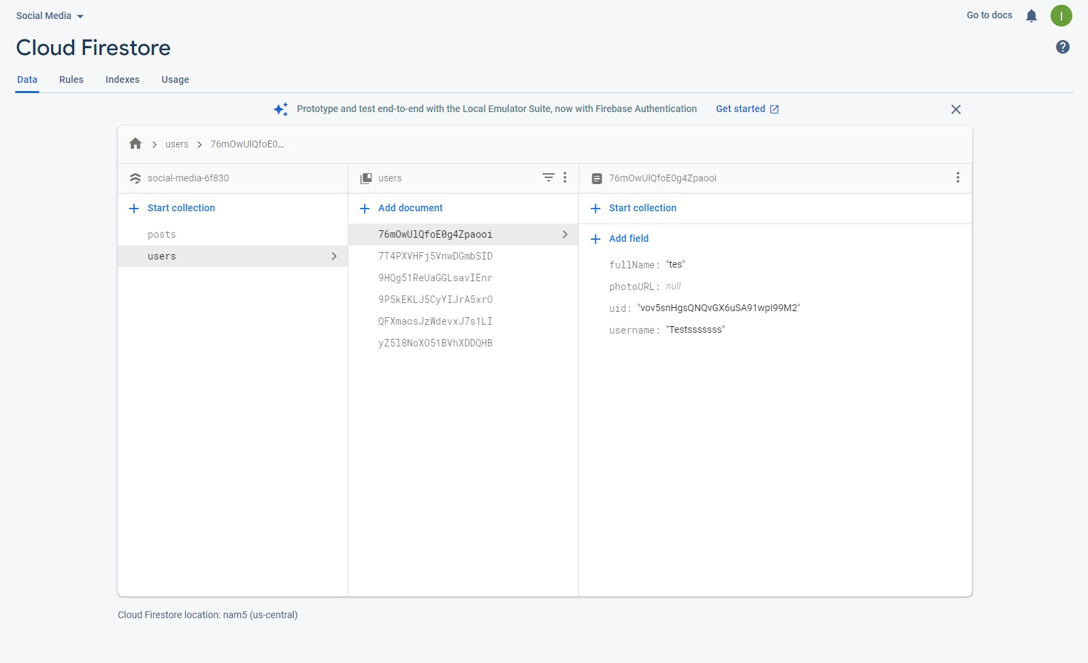

Google analytics plot for your website

Team members contribution

Adam Batat – 20 points
GitHub contributions –
- Created documentations
- Created Balsamiq templates
- Created the database for website
- Created Scrum board tasks
Ian Coston – 20 points
GitHub contributions –
- Created documentations
- Created Balsamiq templates
- Created the frontend for the website
- Recorded the video demonstration and powerpoint

Bryan Perdomo – 20 points
GitHub contributions –
- Created documentations
- Created Balsamiq templates
- Proof read and peer edited code for the website

Colton Johnson – 20 points
GitHub contributions –
- Created documentations
- Created Balsamiq templates
- Created the backend portion of the website
- Created about me template

Mahri Almazova – 20 points
GitHub contributions –
- Created documentations
- Created Balsamiq templates
- Linked the backend to the database
- Created diagrams

